Project Design Phase — Proposed Solution Report
Implement Client Script & UI Policy (Incident)
01 October 2026 | Project Design Phase | SWTID-2026-4755
Field | Project value
Date | 01 October 2026
Team ID | SWTID-2026-4755
Project Name | Implement Client Script & UI Policy (Incident)
Design focus | Specify the solution behavior, novelty, impact, scale, and implementation workflow
1. Proposed solution overview
Implement a coordinated ServiceNow Incident control pattern. A UI Policy named High Impact Control activates when Impact is 1 – High. Its actions make Assignment group mandatory and Urgency read-only. An onChange script sets Urgency to High, an onSubmit script blocks a save when Assigned To is missing, and an onCellEdit script prevents direct State changes from a list.
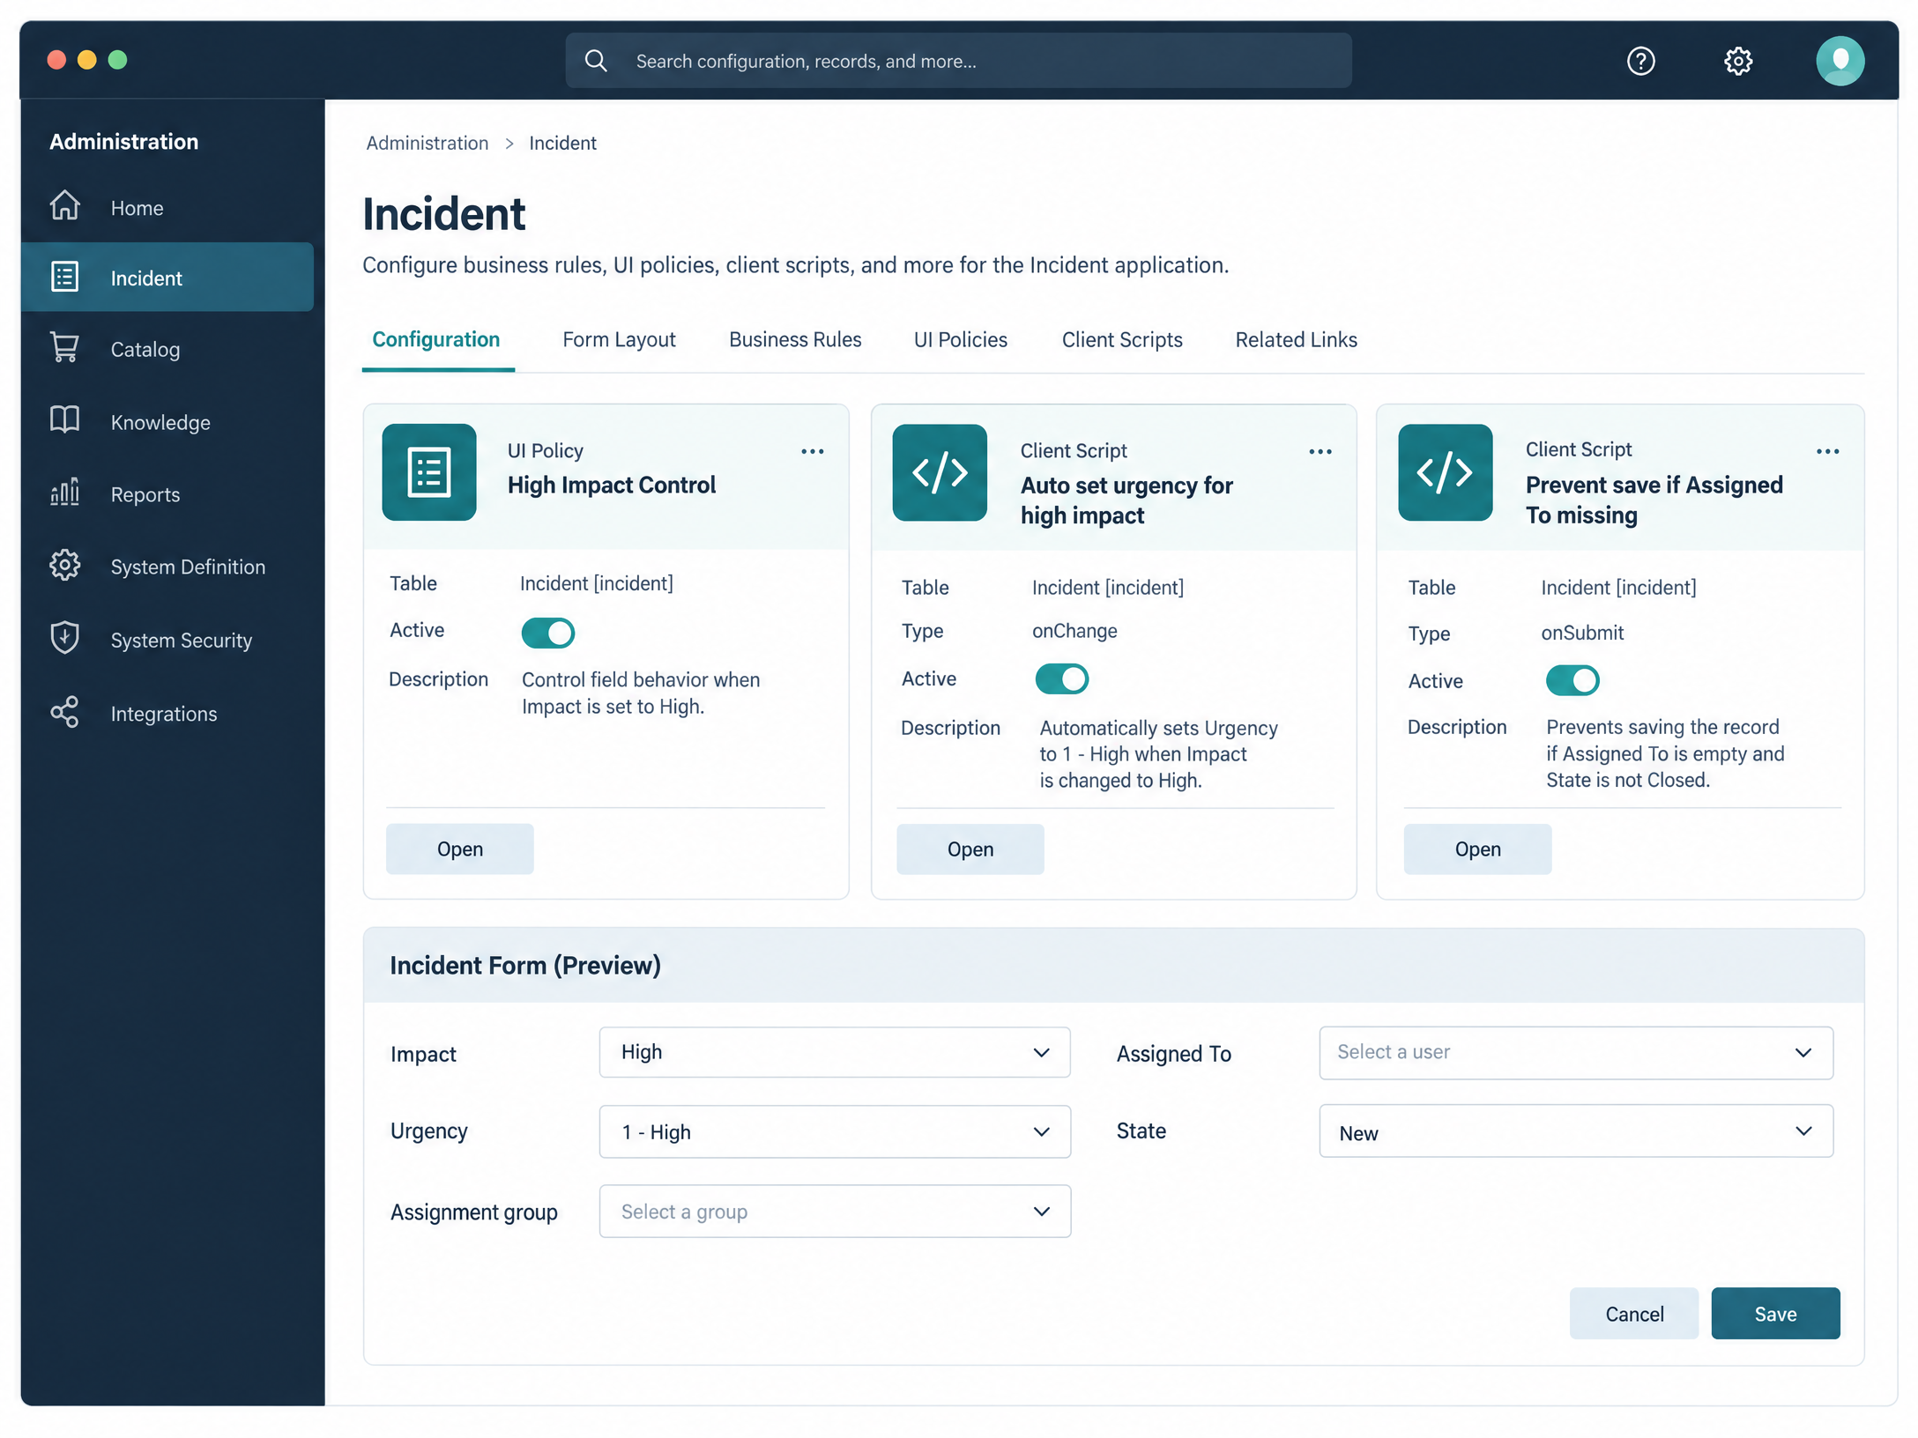
Generated project visual: new ServiceNow administrator configuration workspace for the Incident controls.
2. Solution components
Component | Configuration | Behavior
UI Policy | High Impact Control on Incident; Active = true; Impact is 1 – High; Reverse if false = true. | Activates conditional field behavior only at high impact.
UI Policy Action 1 | Assignment group — Mandatory = true. | Forces a routing destination.
UI Policy Action 2 | Urgency — Read-only = true; visible unchanged. | Prevents conflicting manual urgency entry.
Client Script 1 | Auto set urgency for high impact; onChange; field Impact. | Sets urgency = 1 and displays info message.
Client Script 2 | Prevent save if Assigned To missing; onSubmit. | Shows error and returns false for invalid high-impact save.
Client Script 3 | Prevent state change via list edit; onCellEdit; field State. | Alerts user and callback(false).
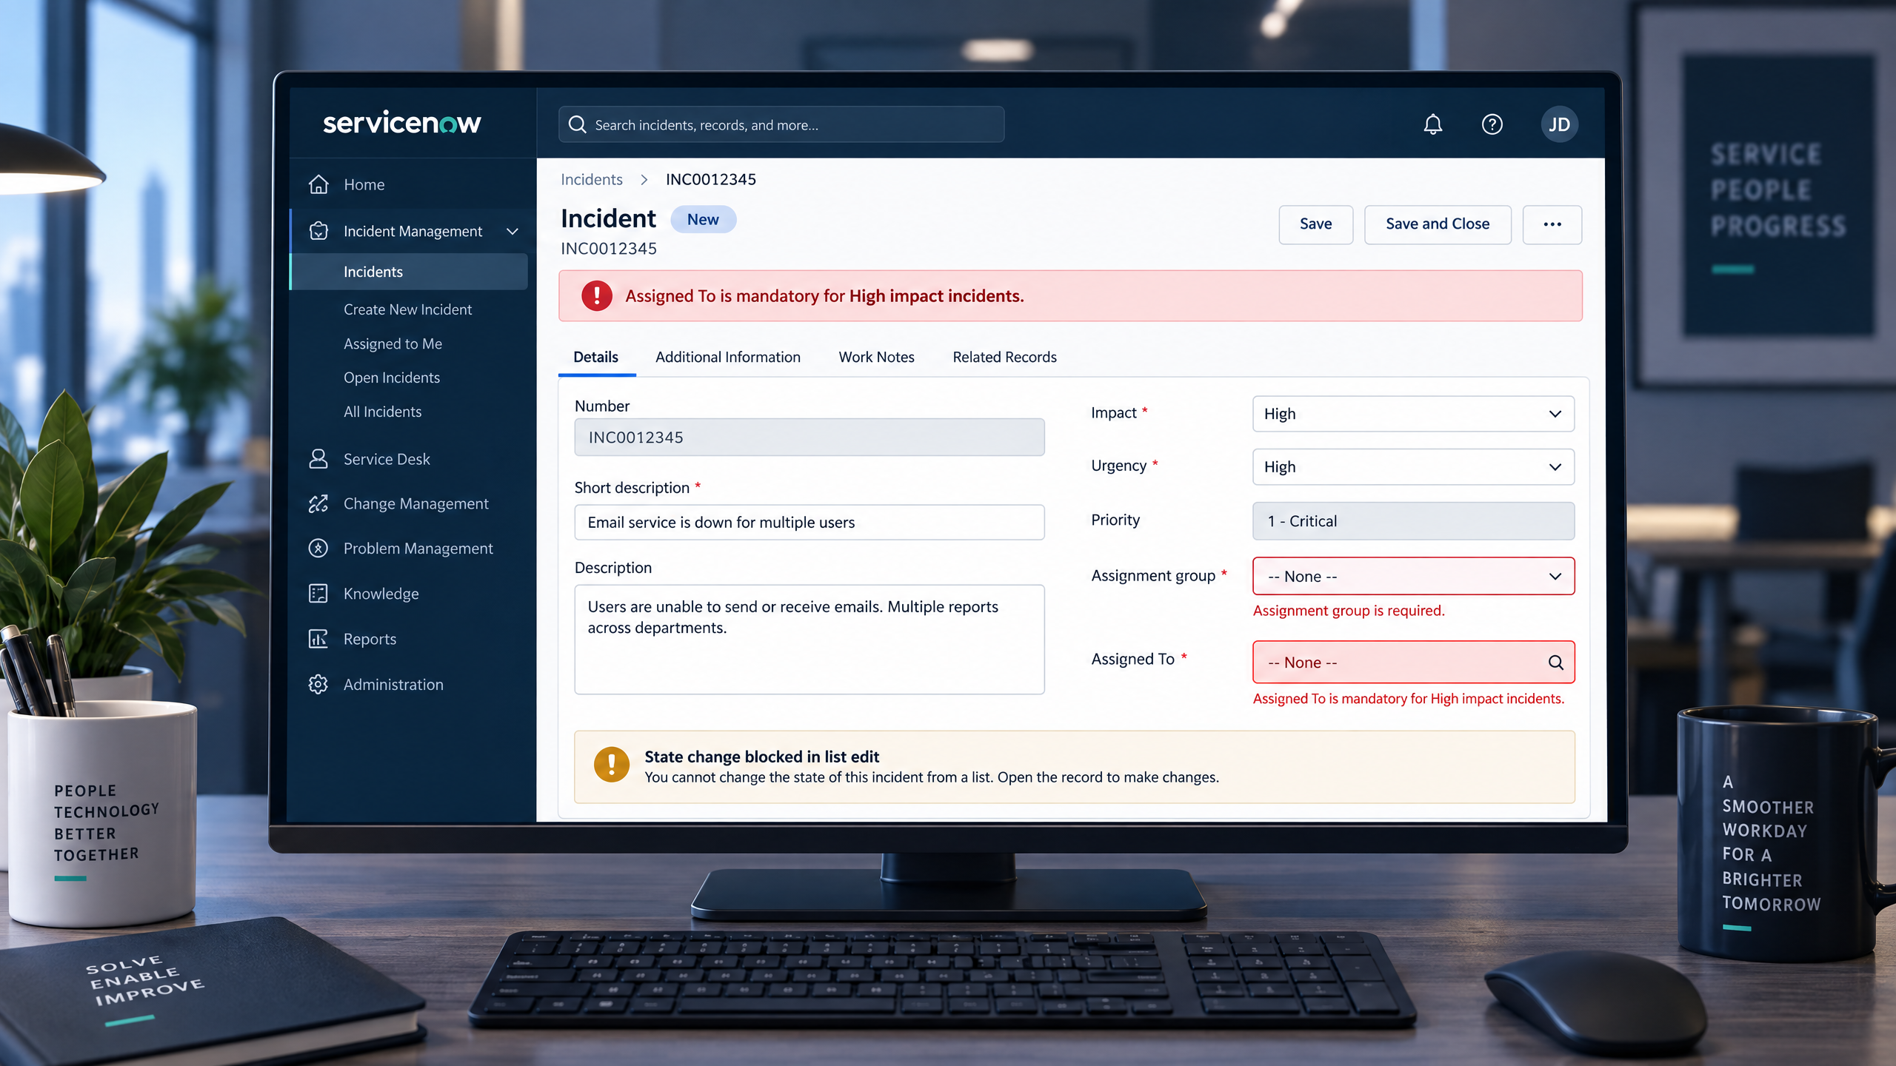
Generated project visual: high-impact Incident form state with actionable validation.
3. Functional workflow
Step | User action | System response
1 | Open or create Incident. | Standard Incident form loads.
2 | Set Impact = High. | UI Policy activates; Assignment group becomes mandatory; Urgency becomes controlled.
3 | Continue without Assigned To. | onSubmit shows an error and prevents save.
4 | Populate Assigned To and submit. | Record saves if other form requirements are satisfied.
5 | Edit State directly from list. | onCellEdit alerts user and rejects the change.
6 | Change State on full form. | Valid form-based update remains allowed.
7 | Change Impact away from High. | Reverse if false restores normal UI behavior.
4. User and business value
• Agents receive guidance at the correct moment instead of after-the-fact correction.
• Incident managers receive more complete ownership and routing information.
• Urgency is aligned with the high-impact signal.
• State transitions are protected from context-free list edits.
• Administrators can troubleshoot named controls by table, type, field, and event.
• Operations avoid a new application stack for a small but important data-quality problem.
5. Novelty / uniqueness
The novelty is the coordinated use of three client-side event types with a reversible UI Policy. The design uses the minimum intervention necessary: conditional controls for high-impact work, automation for repeatable urgency alignment, submit validation for ownership, and list-edit protection for workflow State. It is deliberately explainable rather than artificially complex.
6. Scalability and extension path
Stage | Extension | Reason
Current baseline | Incident Impact/Urgency/Assignment group/Assigned To/State. | Directly matches project PDF.
Hardening | Server-side Data Policy or Business Rule equivalents. | Cover integrations that bypass the form.
Operational analytics | Report incomplete/high-impact records and blocked actions. | Measure quality and rework after rollout.
Workflow expansion | Apply pattern to Priority, Category, major incident, or change processes. | Reuse the design where conditions are explicit.
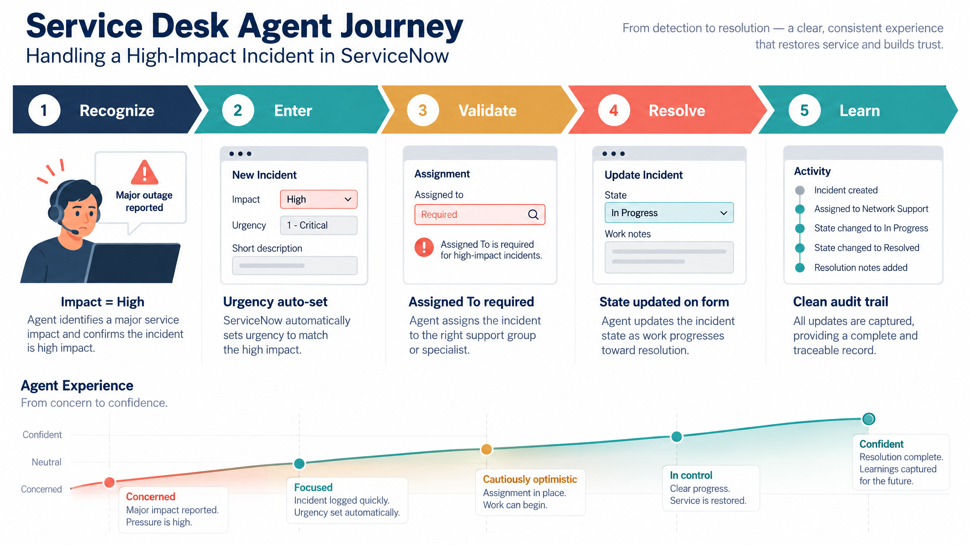
Generated project visual: service desk journey supporting the proposed solution.
7. Implementation workflow
• Create and activate High Impact Control.
• Configure UI Policy Actions for Assignment group and Urgency.
• Create and activate the onChange Client Script on Impact.
• Create and activate the onSubmit Client Script for Assigned To.
• Create and activate the onCellEdit Client Script for State.
• Run positive, negative, reverse-condition, list-edit, and form-update tests.
• Document evidence and prepare administrator handoff.
8. Proposed solution conclusion
This solution is feasible, native, and directly traceable to the project PDF. It delivers visible agent guidance and deterministic data protection while preserving valid workflow updates and leaving a clear path to server-side hardening.

